Emotion and Personality
in a Conversational Character
Gene Ball
Senior Researcher, User Interface Group
Jack Breese
Senior Researcher, Decision Theory and Adaptive Systems Group
Microsoft Research
One Microsoft Way
Redmond, WA 98052
425-936-5653
geneb@microsoft.com, breese@microsoft.com

ABSTRACT
We describe an architecture for constructing a character-based user interface using speech recognition and speech generation. The architecture uses models of emotions and personality encoded as Bayesian networks to 1) diagnose the emotions and personality of the user, and 2) generate appropriate behavior by an automated agent in response to the user's interaction. Classes of interaction that can be interpreted and/or generated include such things as:
- Word choice and syntactic framing of utterances,
- Speech pace, rhythm, and pitch contour, and
- Gesture, expression, and body language.
We also introduce the closely related problem of diagnosing the user’s task orientation, or level of focus on the completion of a particular task (or tasks). This diagnosis is needed to appropriately control system-initiated interactions that could be distracting or inefficient in some situations.

Introduction
Within the human-computer interaction community there is a growing consensus that traditional WIMP (windows, icons, mouse, and pointer) interfaces need to become more flexible, adaptive, and human-oriented (Flanagan 1997). Simultaneously, technologies such as speech recognition, text-to-speech, video input, and advances in computer graphics are providing increasingly rich tools to construct such user interfaces. These trends are driving growing interest in agent- or character-based user interfaces exhibiting quasi-human appearance and behavior.
One aspect of developing such a capability is the ability of the system to recognize the emotional state and personality of the user and respond appropriately (Picard 1995, Reeves 1995). Research has shown that users respond emotionally to their computers. Emotion and personality are of interest to us primarily because of the ways in which they influence behavior, and precisely because those behaviors are communicative-- in human dialogues they establish a channel of social interaction that is crucial to the smoothness and effectiveness of the conversation. In order to be an effective communicant, a computer character needs to respond appropriately to these signals from the user and should produce its own emotional signals that reinforce, rather than confuse, its intended communication.
In this paper we address two crucial issues on the path to what Picard has termed affective computing [Picard 1997]:
- Providing a system with a mechanism to infer the likely emotional state and personality of the user, and
- Providing a mechanism generating behavior in an agent (e.g. speech and gesture) consistent with a desired personality and emotional state.

A Personal Time Management Companion
We are motivated by the requirements of a conversational interface currently under development that communicates with the user via a free-form spoken dialogue. The interface presents itself as an on-screen animated character (using Microsoft Agent [Trower 1997]) called Peedy the Parrot. Peedy is based upon the animated character in an earlier prototype system [Ball 1997b) at Microsoft Research.
Peedy is intended to act as a personal assistant, scheduling events (both work and leisure), generating reminders, informing the user of breaking news, and generally acting as an entertaining companion. Peedy responds to spoken inputs as captured by a large vocabulary continuous speech recognition engine [Huang 1995]. The character’s interaction is controlled by a SpeakEasy script [Ball 1997] in which the character’s responses to likely user inputs have been explicitly authored, augmented by scripts that are periodically generated automatically from sources on the network.

Modeling Emotions and Personality
The understanding of emotion and personality is the focus of an extensive psychology literature. In this work, we adopt a simple model in which current emotional state and long term personality style are characterized by discrete values along a small number of dimensions. These internal states are then treated as unobservable variables in a Bayesian network model. We construct model dependencies based on purported causal relations from these unobserved variables to observable quantities (expressions of emotion and personality) such as word choice, facial expression, speech speed, etc. Bayesian networks are an appropriate tool due to the uncertainty inherent in this domain. The flexibility of dependency structures expressible within the Bayes net framework make it possible to integrate various aspects of emotion and personality in a single model that is easily extended and modified.
Emotion is the term used in psychology to describe short-term variations in internal mental state, including both physical responses like fear, and cognitive responses like jealousy. We focus on two basic dimensions of emotional response [Lang 1995] that can usefully characterize nearly any experience:
- Valence represents overall happiness encoded as positive (happy), neutral, or negative (sad).
- Arousal represents the intensity level emotion, encoded as excited, neutral, or calm.
Personality characterizes the long-term patterns of thought, emotion, and behavior associated with an individual. Psychologists have characterized five basic dimensions of personality, which form the basis of commonly used personality tests. We have chosen to model the two traits [McCrae 1989] that appear to be most critical to interpersonal relationships:
- Dominance indicates a disposition toward controlling or being controlled by others, encoded as dominant, neutral, or submissive.
- Friendliness measures the tendency to be warm and sympathetic, and is encoded as friendly, neutral, or unfriendly.
Psychologists have devised laboratory tests which can reliably measure both emotional state (with physiological sensing such as galvanic skin response and heart rate) and personality (with tests such as the Myers-Briggs Type Indicator [Myers 1985]). A computer-based agent does not have these "sensors" at its disposal, so alternative sources of information must be used.
Our Bayesian network therefore integrates information from a variety of observable linguistic and non-linguistic behaviors as shown in Figure 1. Various classes of these observable effects of personality and emotion are shown in the figure. In the following sections, we discuss the range of behaviors that can be accommodated by our model and describe our architecture for using the model to generate appropriate responses from a conversational assistant.
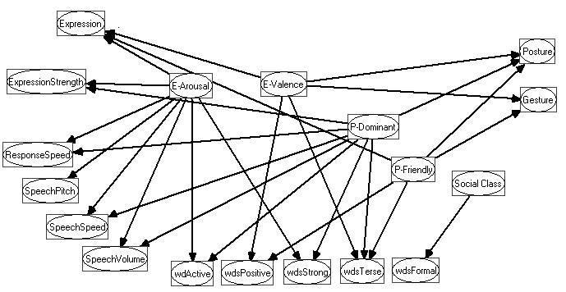
Figure 1: A Bayesian network indicating the components of emotion and personality and various types of observable effects.

Non-Linguistic Expression
Humans communicate their emotional state constantly through a variety of non-verbal behaviors, ranging from explicit (and sometimes conscious) signals like smiles and frowns, to subtle (and unconscious) variations in speech rhythm or body posture. Moreover, people are correspondingly sensitive to the signals produced by others, and can frequently assess the emotional states of one another accurately even though they may be unaware of the observations that prompted their conclusions.
The range of non-linguistic behaviors that transmit information about personality and emotion is quite large. We have only begun to consider them carefully, and list here just a few of the more obvious examples. Emotional arousal affects a number of (relatively) easily observed behaviors, including speech speed and amplitude, the size and speed of gestures, and some aspects of facial expression and posture. Emotional valence is signaled most clearly by facial expression, but can also be communicated by means of the pitch contour and rhythm of speech. Dominant personalities might be expected to generate characteristic rhythms and amplitude of speech, as well as assertive postures and gestures. Friendliness will typically be demonstrated through facial expressions, speech prosody, gestures and posture.
The observation and classification of emotionally communicative behaviors raises many challenges, ranging from simple calibration issues (e.g. speech amplitude) to gaps in psychological understanding (e.g. the relationship between body posture and personality type). However, in many cases the existence of a causal connection is uncontroversial, and given an appropriate sensor (e.g. a gesture size estimator from camera input), the addition of a new source of information to our model will be fairly straightforward.
Within the framework of the Bayesian network of Figure 1, it is a simple matter to introduce a new source of information to the emotional model. For example, suppose we got a new speech recognition engine that reported the pitch range of the fundamental frequencies in each utterance (normalized for a given speaker). We could add a new network node that represents PitchRange with a few discrete values, and then construct causal links from any emotion or personality nodes that we expect to affect this aspect of expression. In this case, a single link from Arousal to PitchRange would capture the significant dependency. Then the model designer would estimate the distribution of pitch ranges for each level of emotional arousal, to capture the expectation that increased arousal leads to generally raised pitch. The augmented model would then be used both to recognize that increased pitch may indicate emotional arousal in the user, as well as adding to the expressiveness of a computer character by enabling it to communicate heightened arousal by adjusting the base pitch of its synthesized speech.

Selection of Words and Phrases
A key method of communicating emotional state is by choosing among semantically equivalent, but emotionally diverse paraphrases-- for example, the difference between responding to a request with “sure thing”, “yes”, or “if you insist”. Similarly, an individual's personality type will frequently influence their choice of phrasing, e.g.: “you should definitely” vs. “perhaps you might like to”.
In the context of our scripted agents, we have identified a number of communication concepts for which we can enumerate a variety of alternative paraphrases. Some examples are shown in Table 1. Our Bayesian model is then used to relate these paraphrases to the emotional and personality messages that they communicate.
Concept | Paraphrases
Greeting | Hello  hi there  howdy | Greetings  Hey
Yes | Yes  Yeah  I think so | Absolutely  I guess so  for sure
Suggest | I suggest that you  perhaps you would like to  maybe you could | you should  let's
Table 1: Paraphrases for alternative concepts.
Assessing the likelihood of each alternative paraphrase for every combination of personality type and emotional state would be quite difficult. In order to reduce this burden, we model the influence of emotion and personality on wording choice in two stages. First, the network shown in Figure 1 contains nodes representing several classes of expressive style. The current model represents active, positive, terse, and strong expression. These nodes capture the influence of personality and emotion on the expressive style that an individual is likely to use. Then, each paraphrase of a basic concept is assessed along the same expressive dimensions, to reflecting the general cultural interpretation of that phrase. For example, this assessment estimates the likelihood that “perhaps you would like to” will be perceived as a strong way of expressing a suggestion. These assessments are then used to construct a Bayesian sub-network that evaluates the degree of match between a particular paraphrase and the user’s personality and emotional state.

Interaction Architecture
In the agent we maintain 2 copies of the emotion/personality model. One is used to diagnose the user, the other to generate behavior for the agent. The basic setup is shown in Figure 2. In the following, we will discuss the procedures used in this architecture, referring to the numbered steps in the figure.

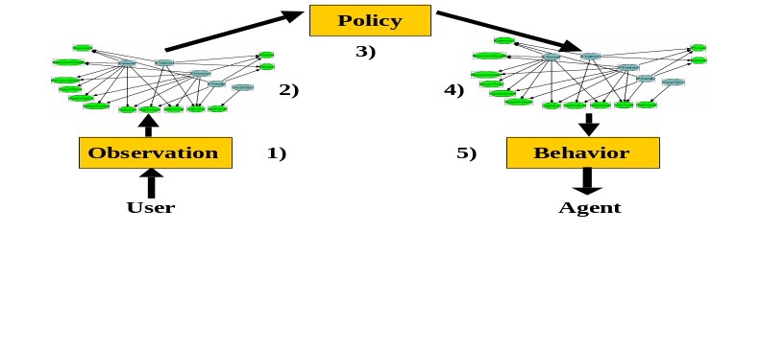
Figure 2: An architecture for speech and interaction interpretation and subsequent behavior generation by a conversational character.
- Observe. This step refers to recognizing an utterance as one of the possible paraphrases for a concept. At a given point in the dialog, for example after asking a yes/no question, the speech recognition engine is listening for all possible paraphrases for the speech concepts yes and no. When one is recognized, the corresponding node in the user Bayesian network is set to the appropriate value.
- Update. Here we use a standard probabilistic inference [Jensen 1989, Jensen 1996] algorithm to update estimates of personality and emotional state given the observations.
- Agent Response. The linkage between the models is captured in the agent response component. This is the mapping from the updated probabilities of the emotional states and personality of the user to the emotional state and personality of the agent. The response component can be designed to develop an empathetic agent, whose mood and personality matches that of the user, or a contrary agent, whose emotions and personality tend to be the exact opposite of the user. Research has indicated that users prefer a computerized agent to have a personality makeup similar to their [Reeves 1995], so by default our prototypes implement the empathetic response policy.
- Propagate. Again we use a probabilistic inference algorithm to generate probability distributions over paraphrases, animations, speech characteristics, etc. consistent with the emotional state and personality set by the response module.
- Generate Behavior. At a given stage of the dialog, the task model may dictate that the agent express a particular concept, for example greet or regret. We then consult the agent Bayesian network for the current distribution over the possible paraphrases for expressing that concept. We sample from that distribution to select a particular paraphrase, and pass that string to the text-to speech engine for generating output. Similar techniques are used to generate animations, and adjust speech speed and volume.

The Problem of Task Orientation
In addition to personality and emotion, consideration of the time management companion as an application has suggested an additional important dimension of the user’s state, which we call task orientation. This phrase is intended to correspond to the degree or intensity with which the user is currently pursuing a specific goal. When the user’s task orientation is high, a responsible assistant should recede to the background, providing terse, specific replies only when directly requested. However, since one of Peedy’s objectives is to entertain as well as to serve, he often initiates interaction (to inform of late-breaking Web news, for example) or engages in amusing background behaviors. Therefore diagnosis of the user’s degree of task orientation would be a useful addition to the application’s control state.
The Bayesian network of Figure 1 can be extended to model an additional unobservable variable that represents Task Orientation. We hypothesize that when highly focused, a user is likely to demonstrate behaviors consistent with a more dominant and less friendly personality than normal. In addition, negative emotional events (such as interaction failures) are likely to generate stronger reactions (higher levels of arousal) than when task orientation is low. High levels of activity with other applications (typing & mouse clicking rates) also are indicative of high task orientation. Thus, observation of such behaviors should be interpreted as evidence that the user is highly oriented towards task completion.
In our current design thinking, estimates of task orientation affect the behavior of the character in two primary ways.
- Terse responses should be strongly preferred when the user is highly focused. In order to avoid monotony in the character’s verbal expression, our scripting language has mechanisms for randomly selecting among alternative utterances, and this terseness constraint can be applied at that point.
- When the system considers initiating an unrequested interaction like a news report, joke, or even a distracting idle behavior, a high task orientation should greatly reduce the frequency of interruption. More importantly, the response to an interruption may provide the best evidence of the user’s actual task status.

Conclusion
This paper presents work in progress in developing adaptive conversational user interfaces. We have presented a reasoning architecture for an agent that can recognize a user's personality and emotional state and respond appropriately in a non-deterministic manner.

REFERENCES
[Ball 1997] Ball, G. (1997). The SpeakEasy Dialogue Controller. First International Workshop on Human-Computer Conversation, Bellagio, Italy.
[Ball 1997] Ball, G., Ling, D., Kurlander, D., Miller, J., Pugh, D., et al. (1997). Lifelike Computer Characters: The Persona Project at Microsoft Research. Software Agents. J. M. Bradshaw. Menlo Park, California, AAAI Press/The MIT Press: 191-222.
[Flanagan 1997] Flanagan, J., Huang, T., Jones, P. and Kasif, S. (1997). Final Report of the NSF Workshop on Human-Centered Systems: Information, Interactivity, and Intelligence. Washington, D.C., National Science Foundation.
[Huang 1995] Huang, X., Acero, A., Alleva, F., Hwang, M. Y., Jiang, L., et al. (1995). Microsoft Windows Highly Intelligent Speech Recognizer: Whisper. Proceedings of the IEEE International Conference on Acoustics, Speech, and Signal Processing, Detroit, MI.
[Jensen 1996] Jensen, F. V. (1996). An Introduction to Bayesian Networks. New York, New York, Springer-Verlag.
[Jensen 1989] Jensen, F. V., L., L. S. and G., O. K. (1989). Bayesian updating in recursive graphical models by local computations., Institute for Electronic Systems, Department of Mathematics and Computer Science, University of Aalborg, Denmark.
[Lang 1995] Lang, P. (1995). “The emotion probe: Studies of motivation and attention.” American Psychologist 50(5): 372-385.
[McCrae 1989] McCrae, R. and Costa, P. T. (1989). “The structure of interpersonal traits: Wiggin's circumplex and the five factor model.” Journal of Personality and Social Psychology 56(5): 586-595.
[Myers 1985] Myers, I. B. and McCaulley, M. H. (1985). Manual: A Guide to the development and use of the Myers-Briggs Type Indicator. Palo Alto, California, Consulting Psychologists Press.
[Picard 1995] Picard, R. W. (1995). Affective Computing. Cambridge, Massachusetts, M.I.T. Media Lab.
[Picard 1997] Picard, R. W. (1997). Affective Computing. Cambridge, Massachusetts, MIT Press.
[Reeves 1995] Reeves, B. and Nass, C. (1995). The Media Equation. New York, New York, CSLI Publications and Cambridge University Press.
[Trower 1997] Trower, T. (1997). Microsoft Agent. Redmond, WA, Microsoft Corporation,http://www.microsoft.com/msdn/sdk/inetsdk/help/msagent/agent.htm.

